LOAD BALANCER-APPLICATION LOAD BALANCER

Create two instances named as ALB-1,ALB-2

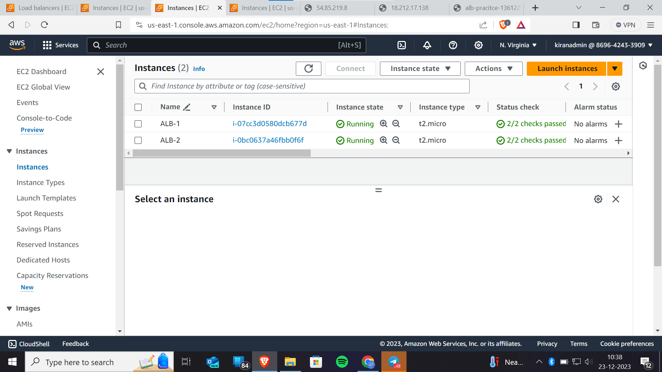

Here we have to take atmost care while creating the ec2 instance

Prerequisite-1

1)proceed without a keypair

2)security group which is having the protocols HTTP,SSH from anywhere

3)In additional settings, paste the given script.

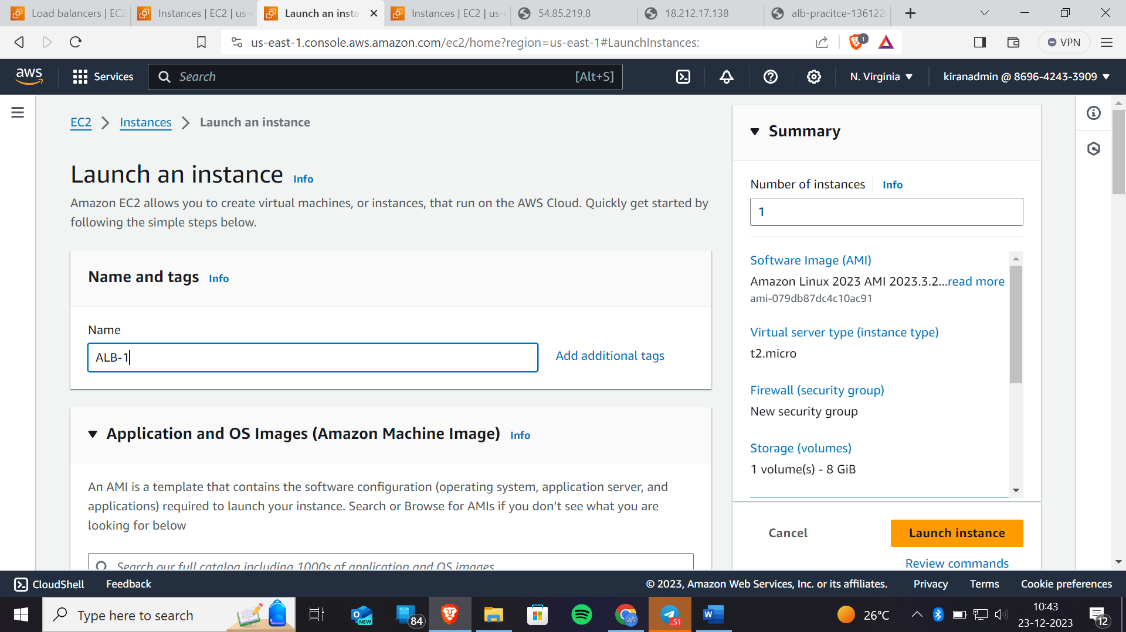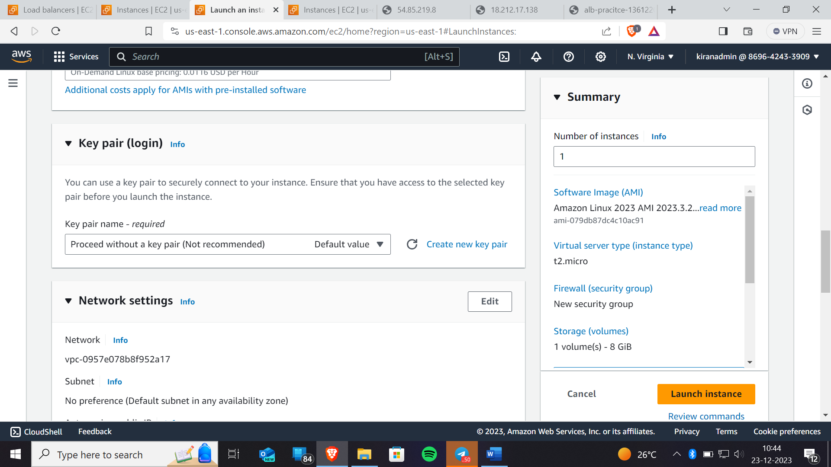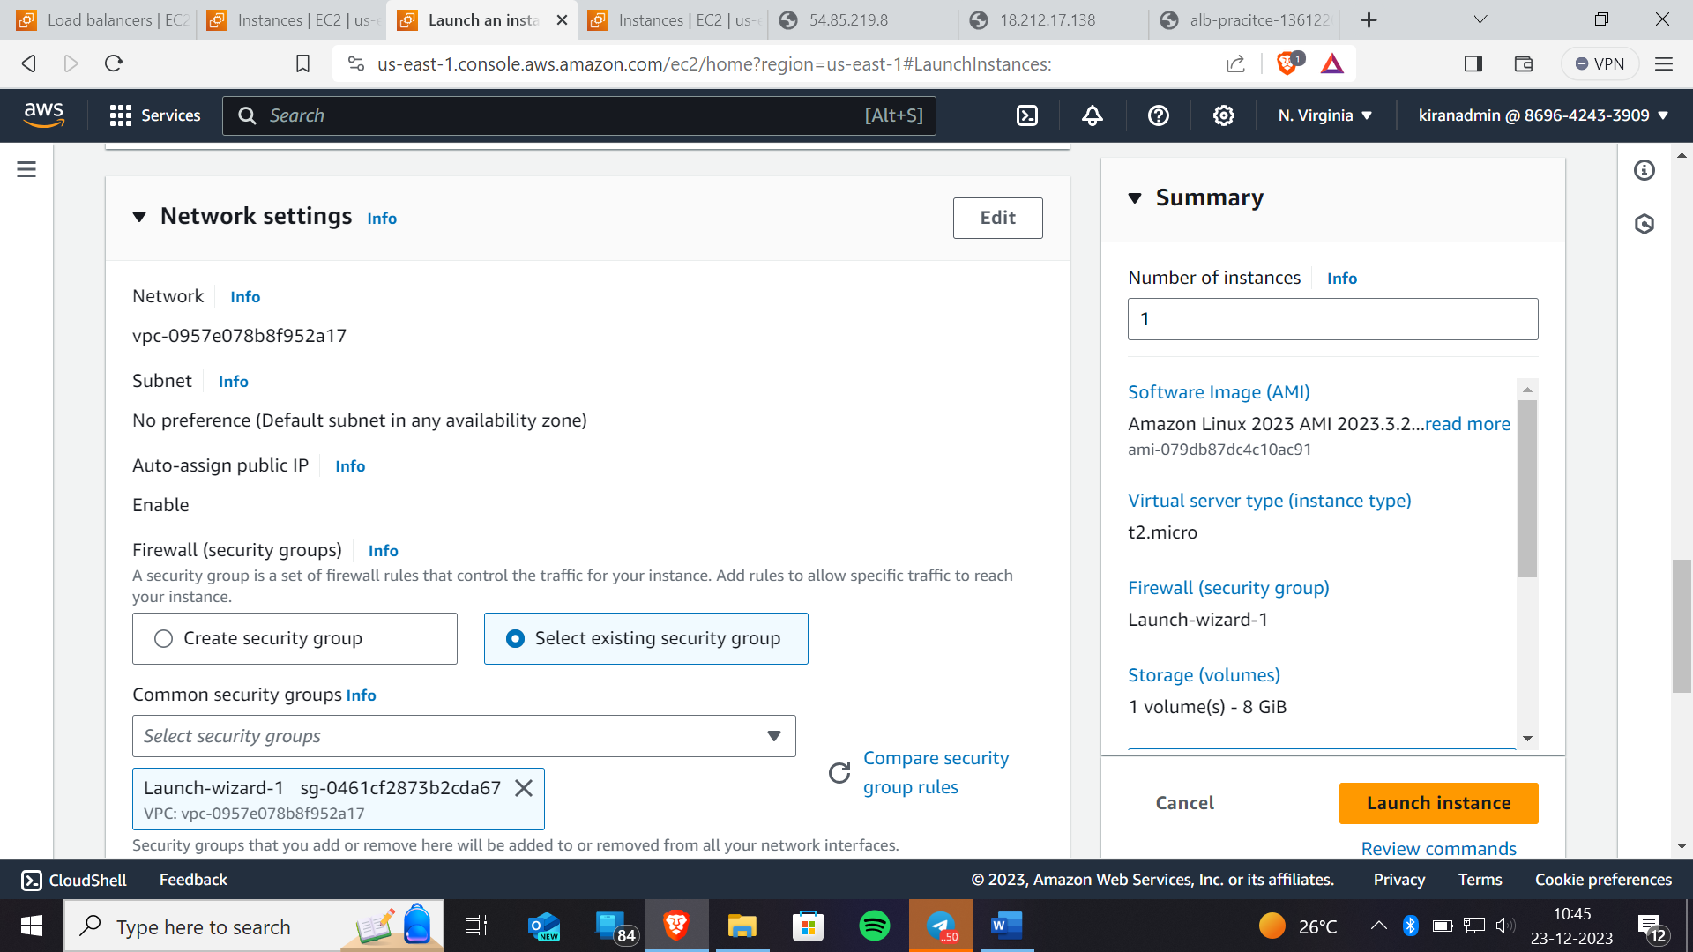Here we have created a launch-wizard-1 security group and while creating this security group I have created 2- protocols which are http and ssh from any where



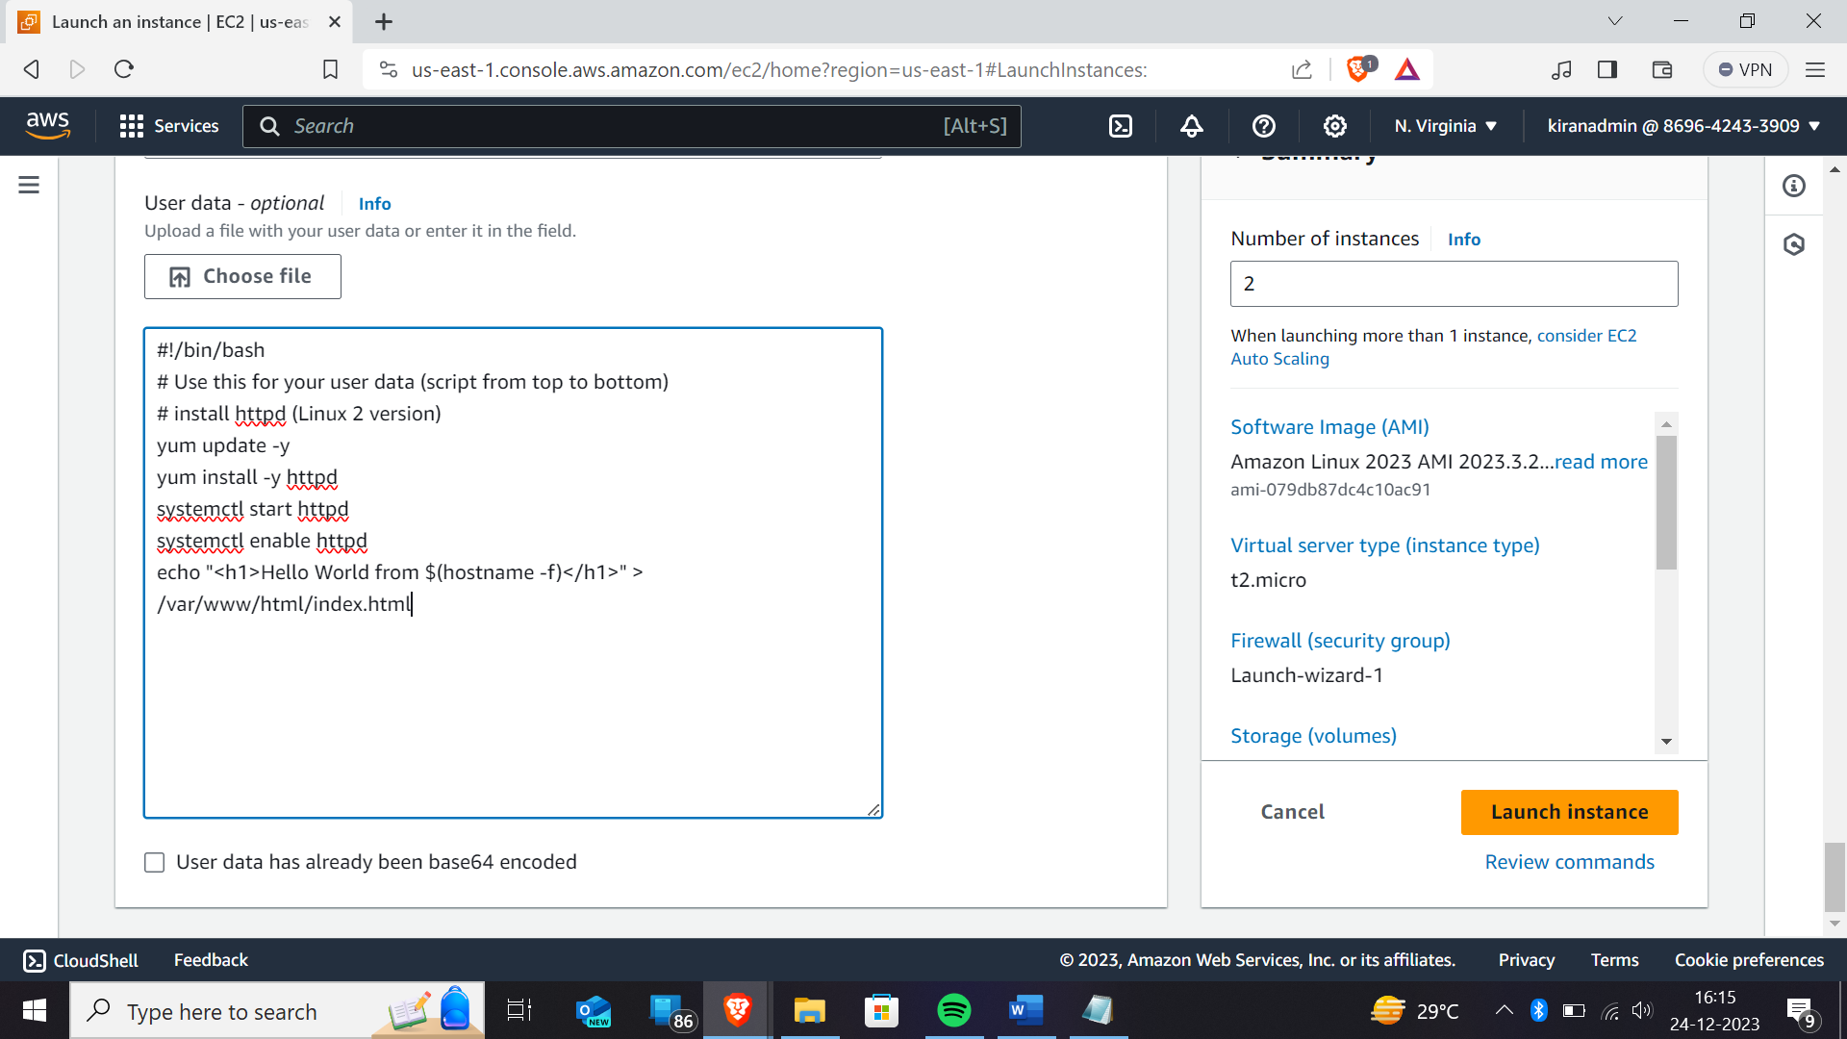



Paste the given script in the advanced settings user data

#!/bin/bash

# Use this for your user data (script from top to bottom)

# install httpd (Linux 2 version)

yum update -y

yum install -y httpd

systemctl start httpd

systemctl enable httpd

echo "<h1>Practising Application Load balancer $(hostname -f)</h1>" > /var/www/html/index.html

PASTE THE ABOVE CODE ONLY

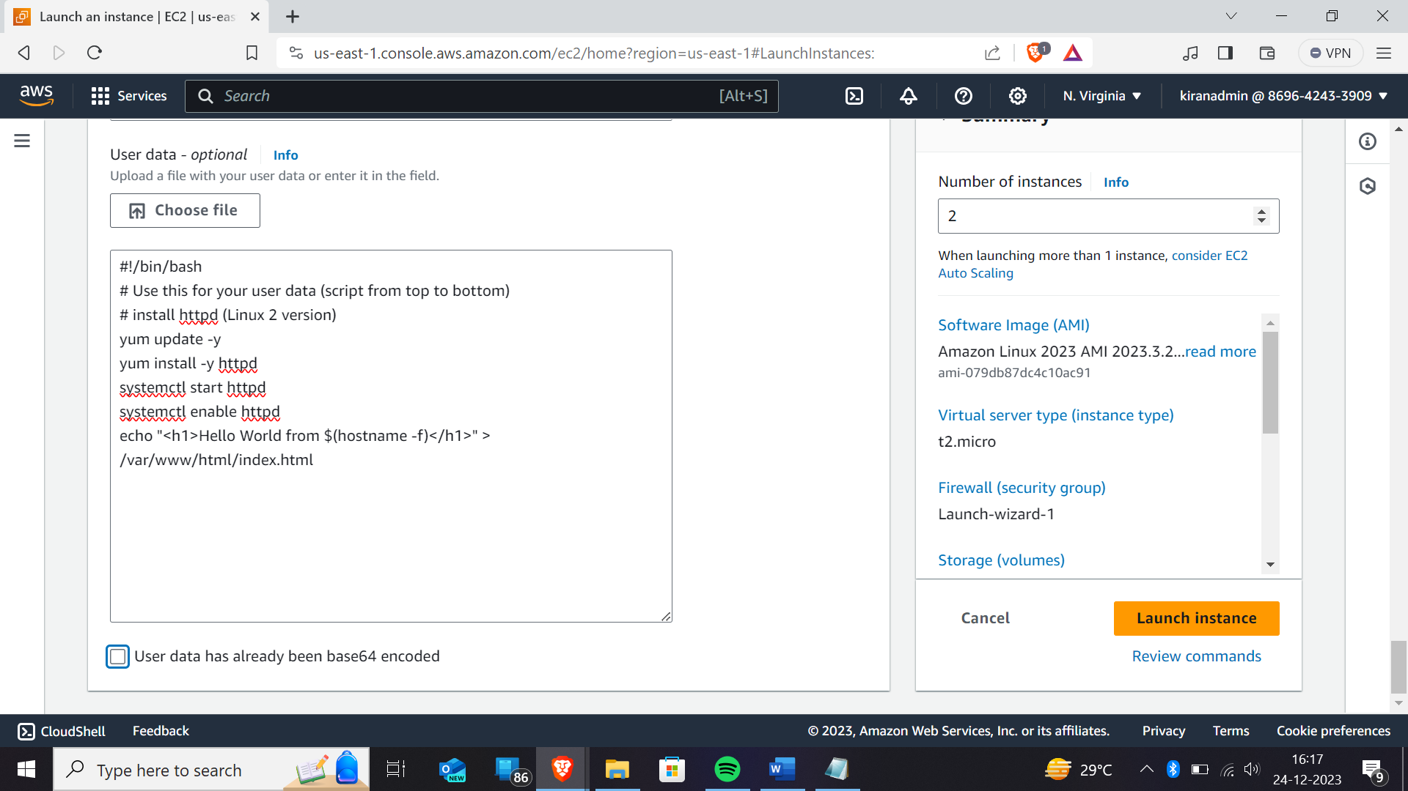Number of instances we have to create is 2 instances because we have to transfer the load to one ec2 instance to another ec2 instance



Now click on launch instance.

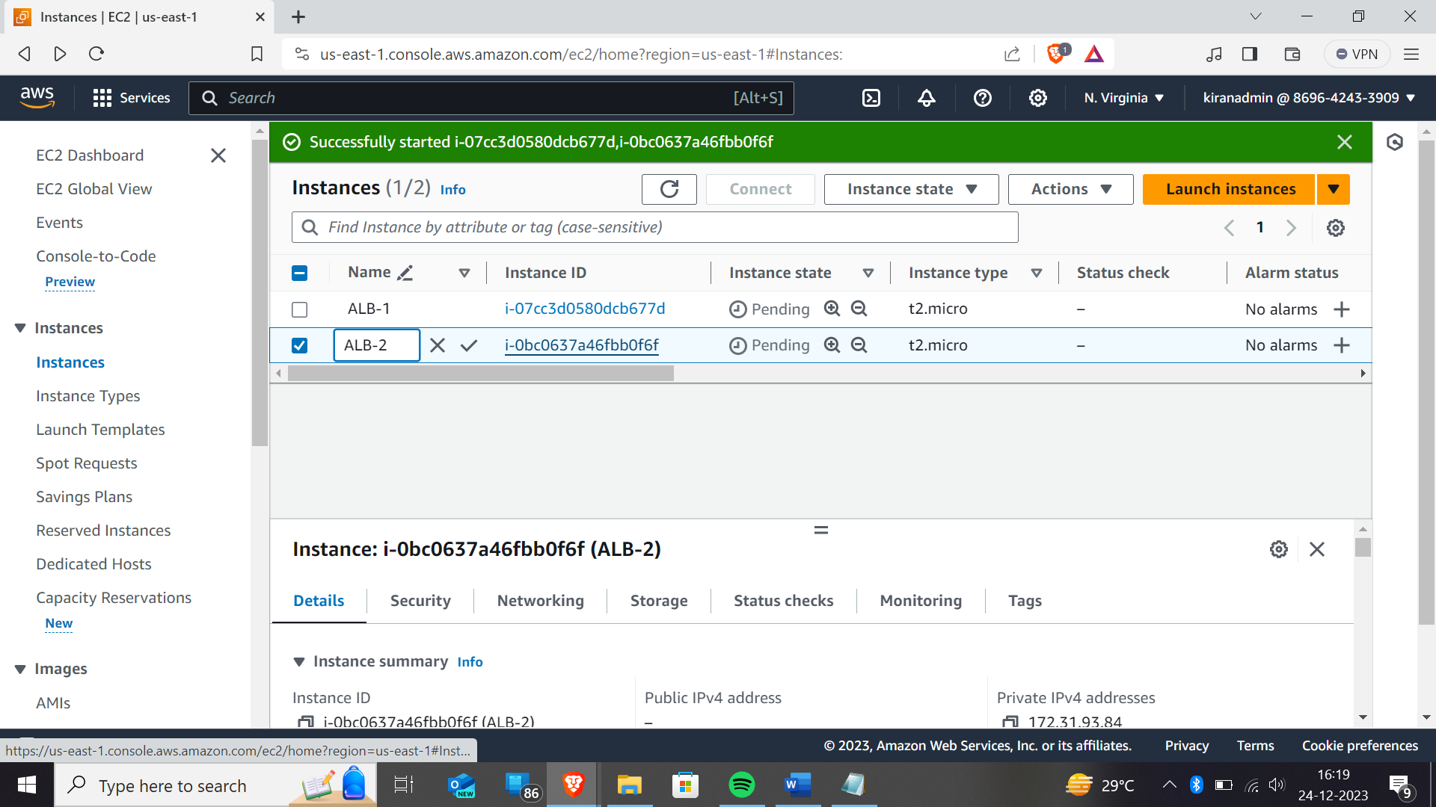In this you can rename the instances as whatever the name you want you can give here.



Now we have to check,whether the instance is working properly or not. So for that you have to copy the public ipaddress and paste it in the new tab as shown below



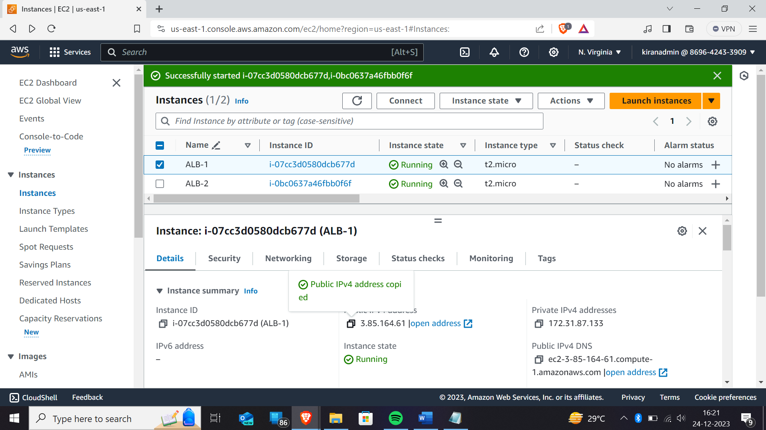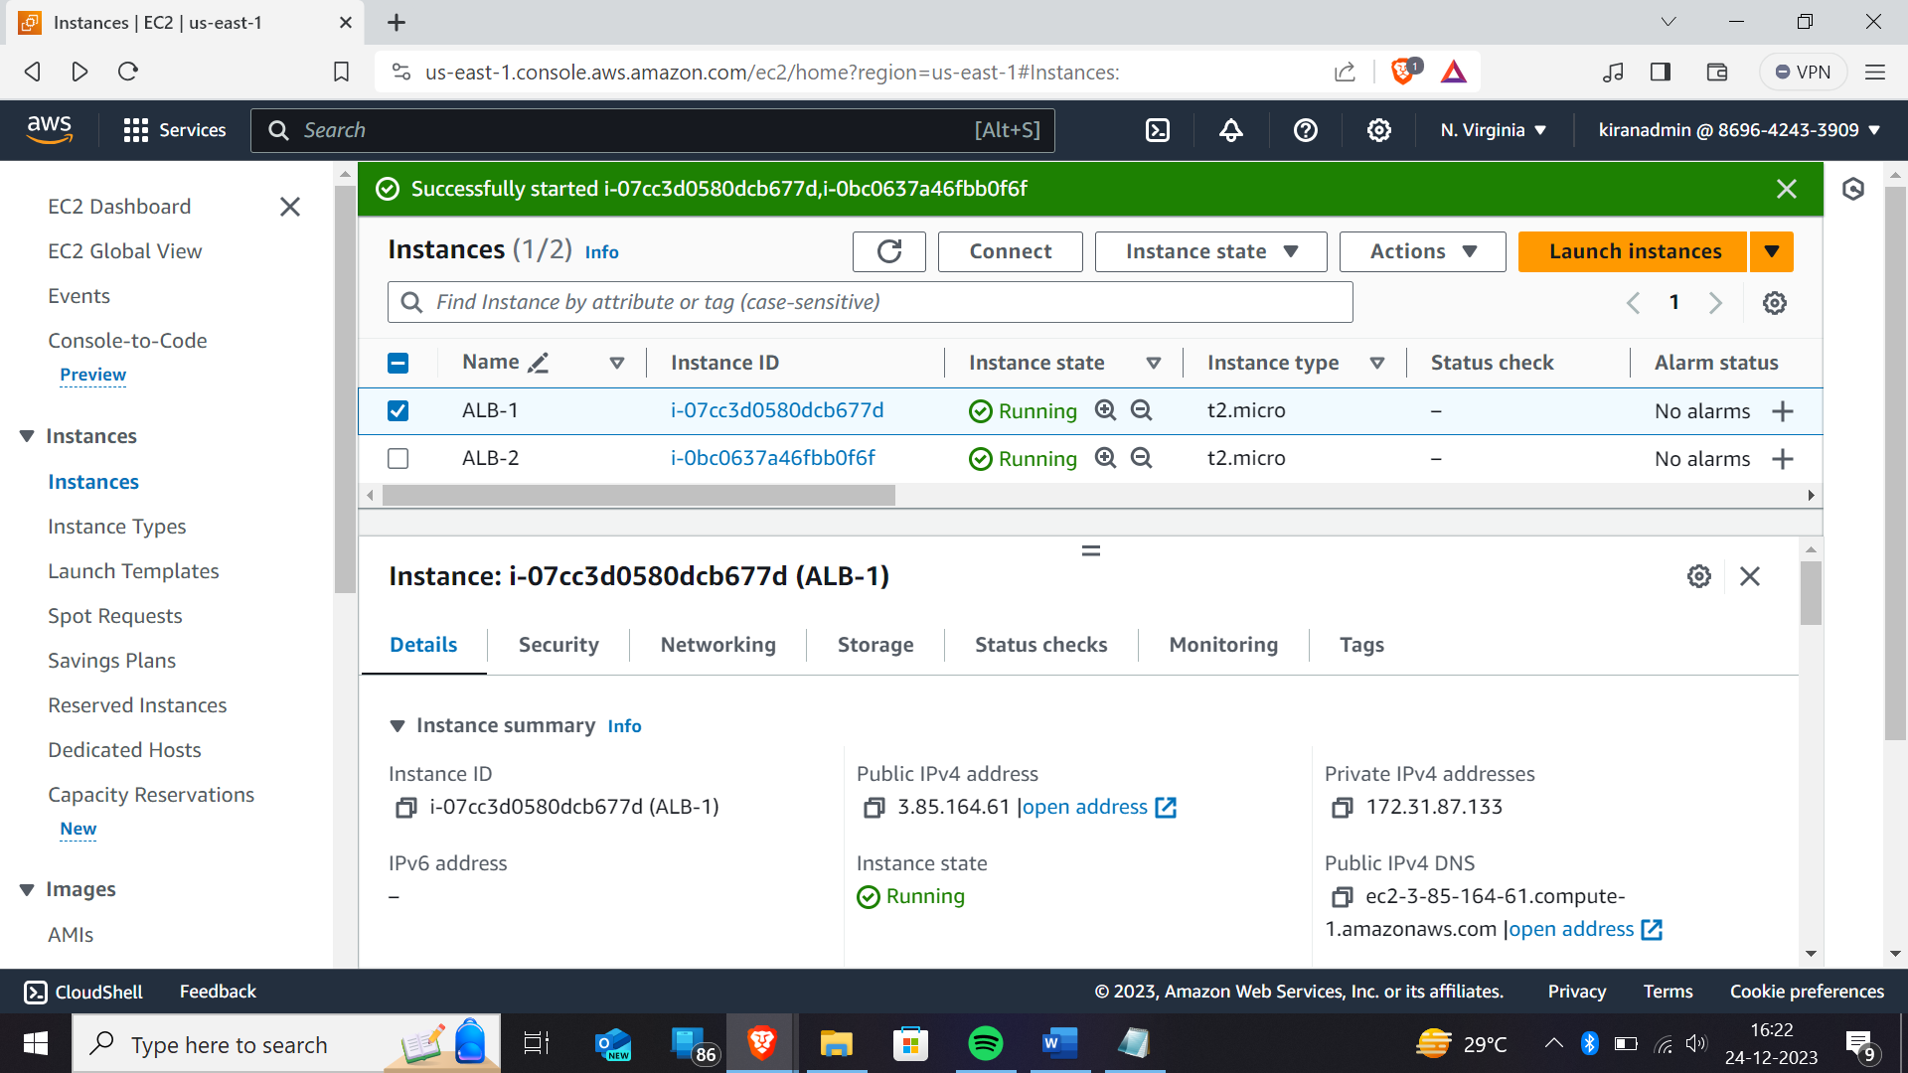

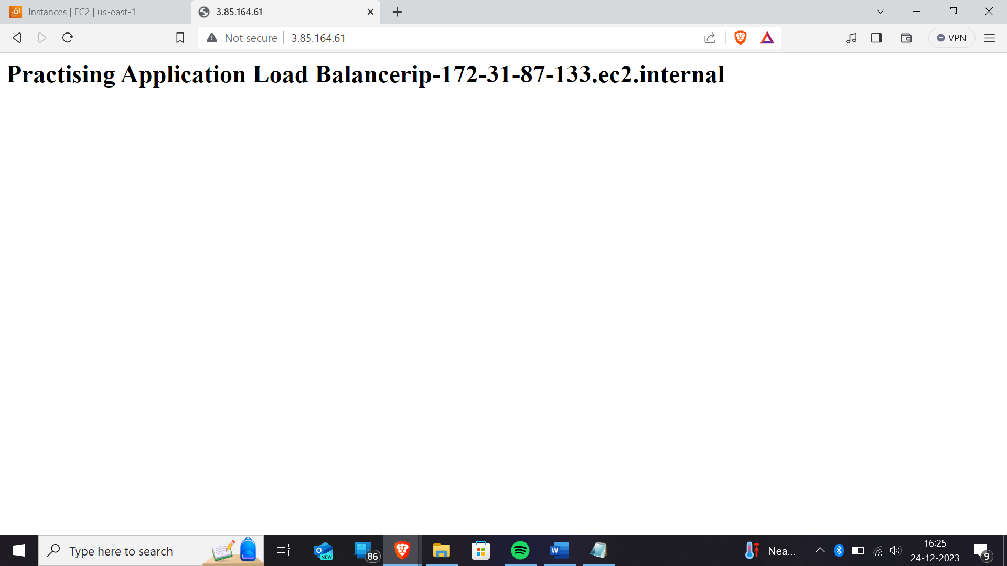The page will be like this if you are not getting like this please use this format

<http://’ipaddress>’

Like that copy the public ip address of second instance and paste in the another tab

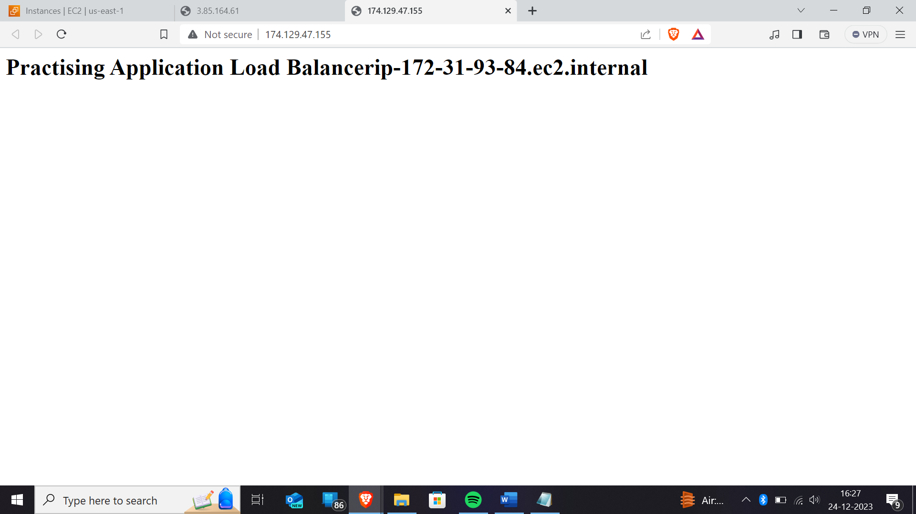

Now we have to create “APPLICATION LOAD BALANCER”

Go to the load balancer module

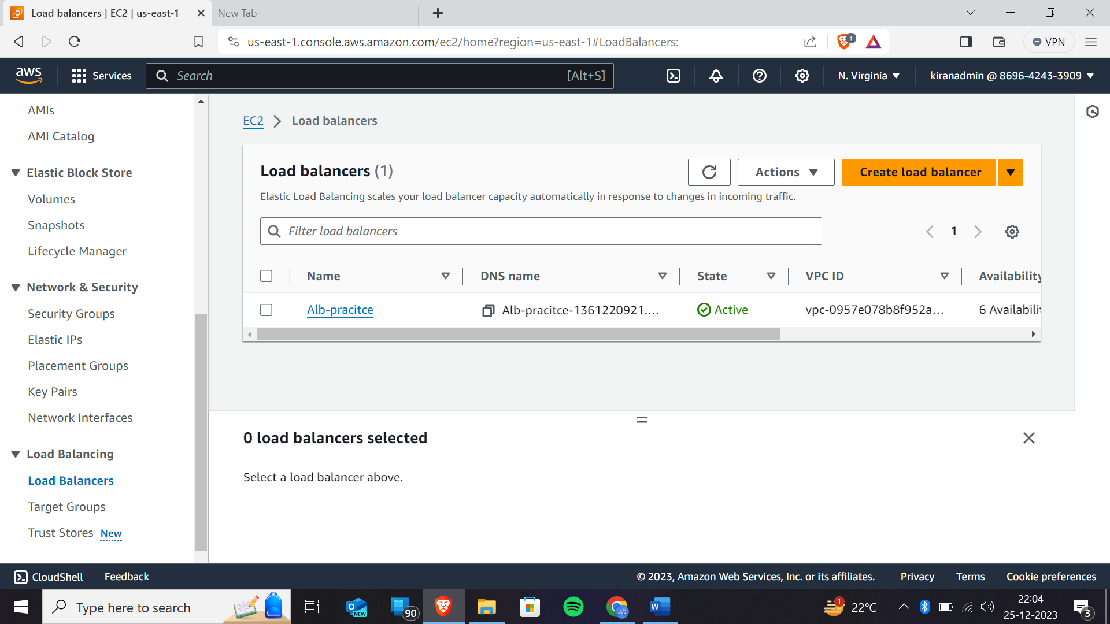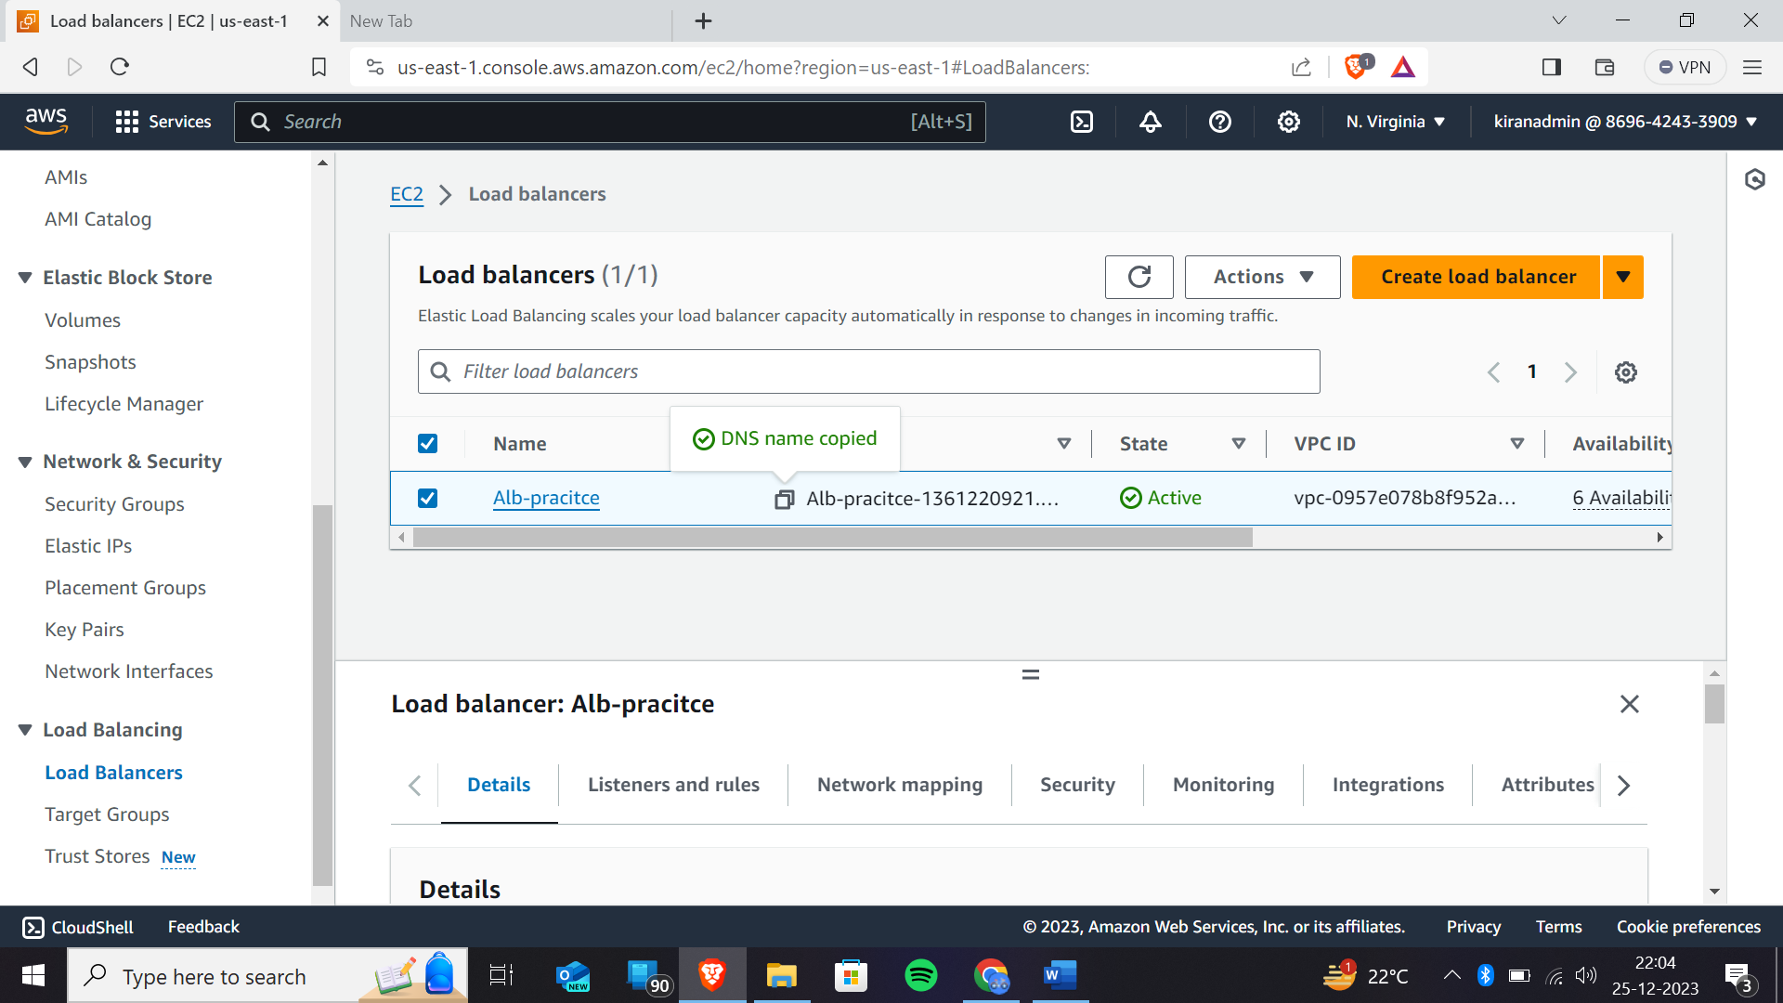Copy the DNS name and paste it in the new tab

Output

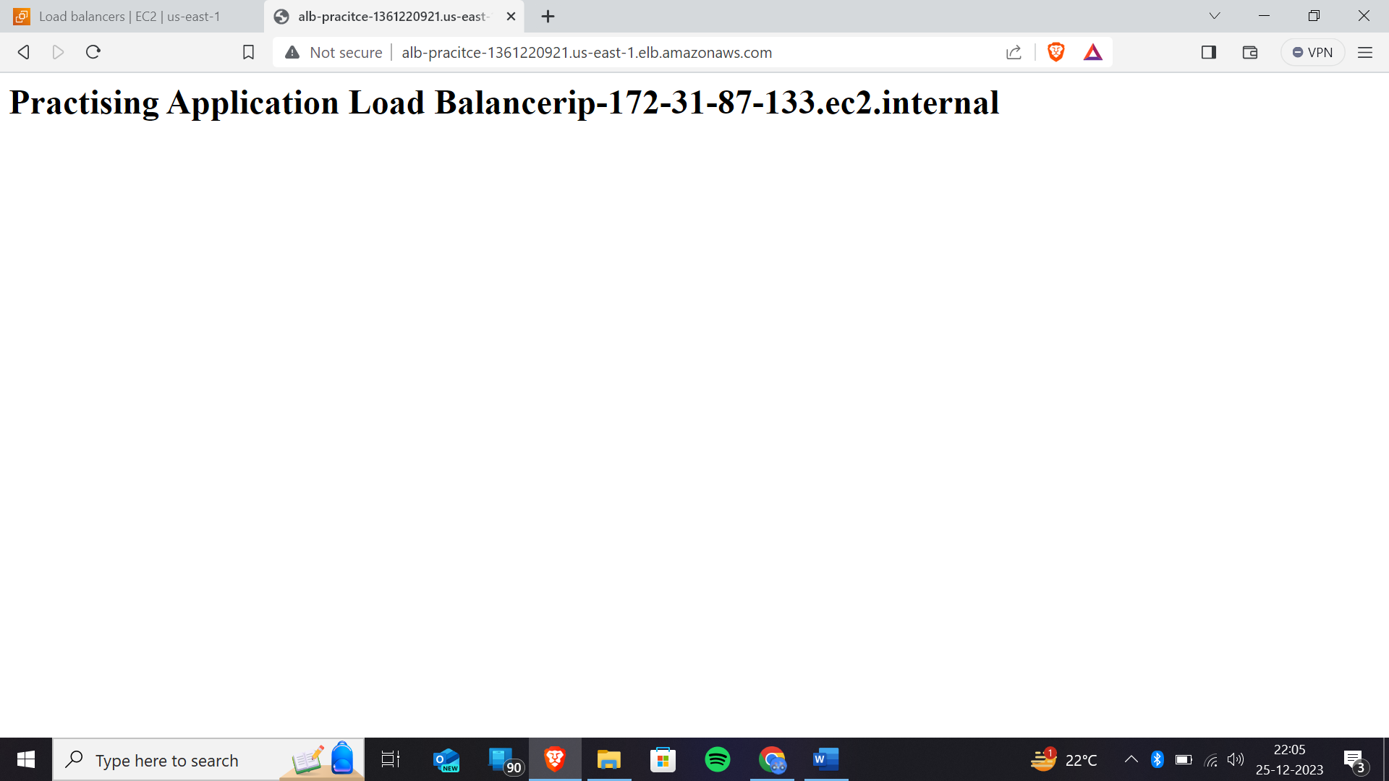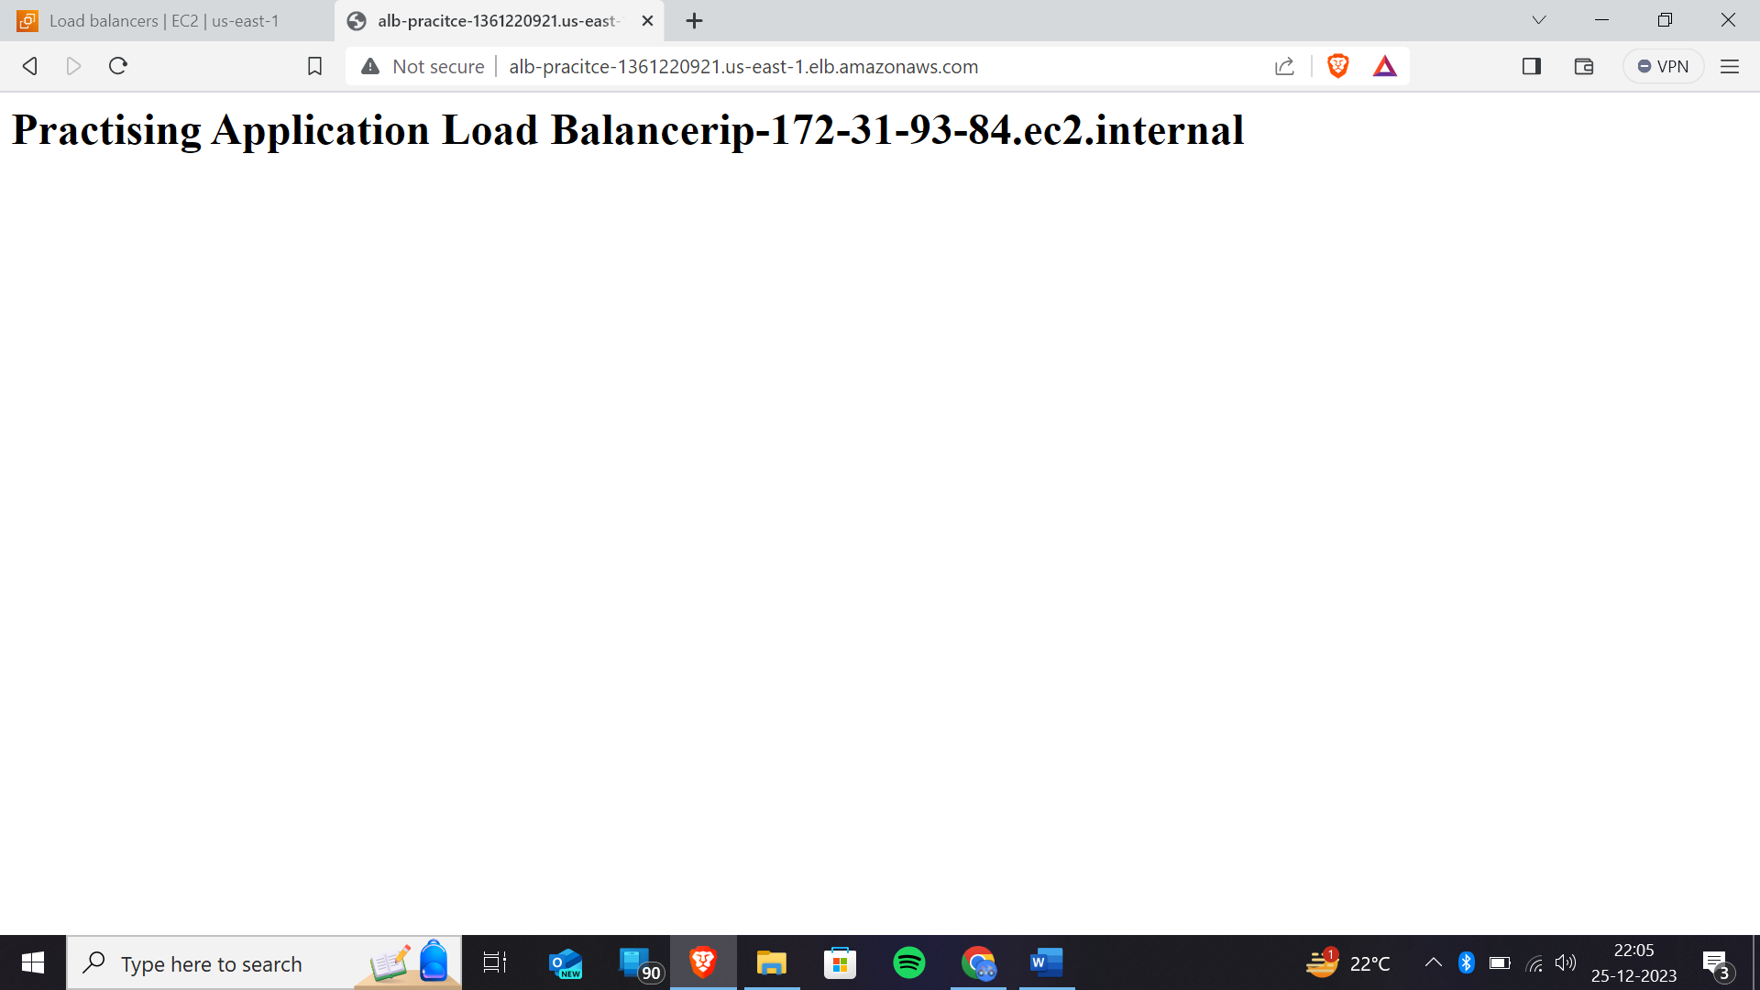when you reload that page the load balancer will redirect the page from one page to the another page.

Hence, we can see that load is redirected to another instance , when we reload the page.

And next step we have to concentrate on the ‘security’

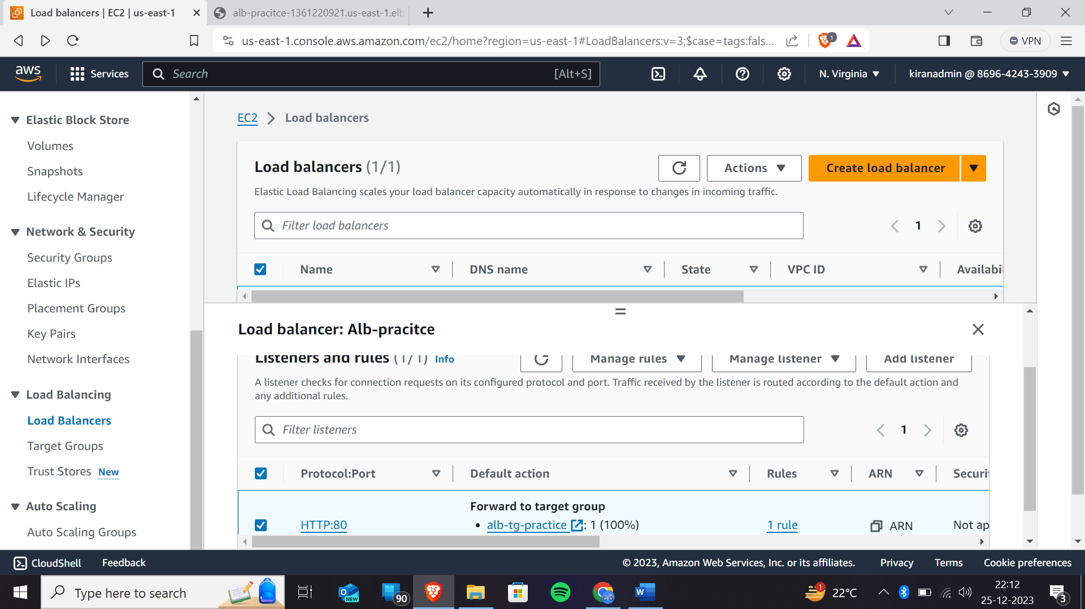Click on listeners and rules and select that so that you will get the access to manage rules🡪’add rules’

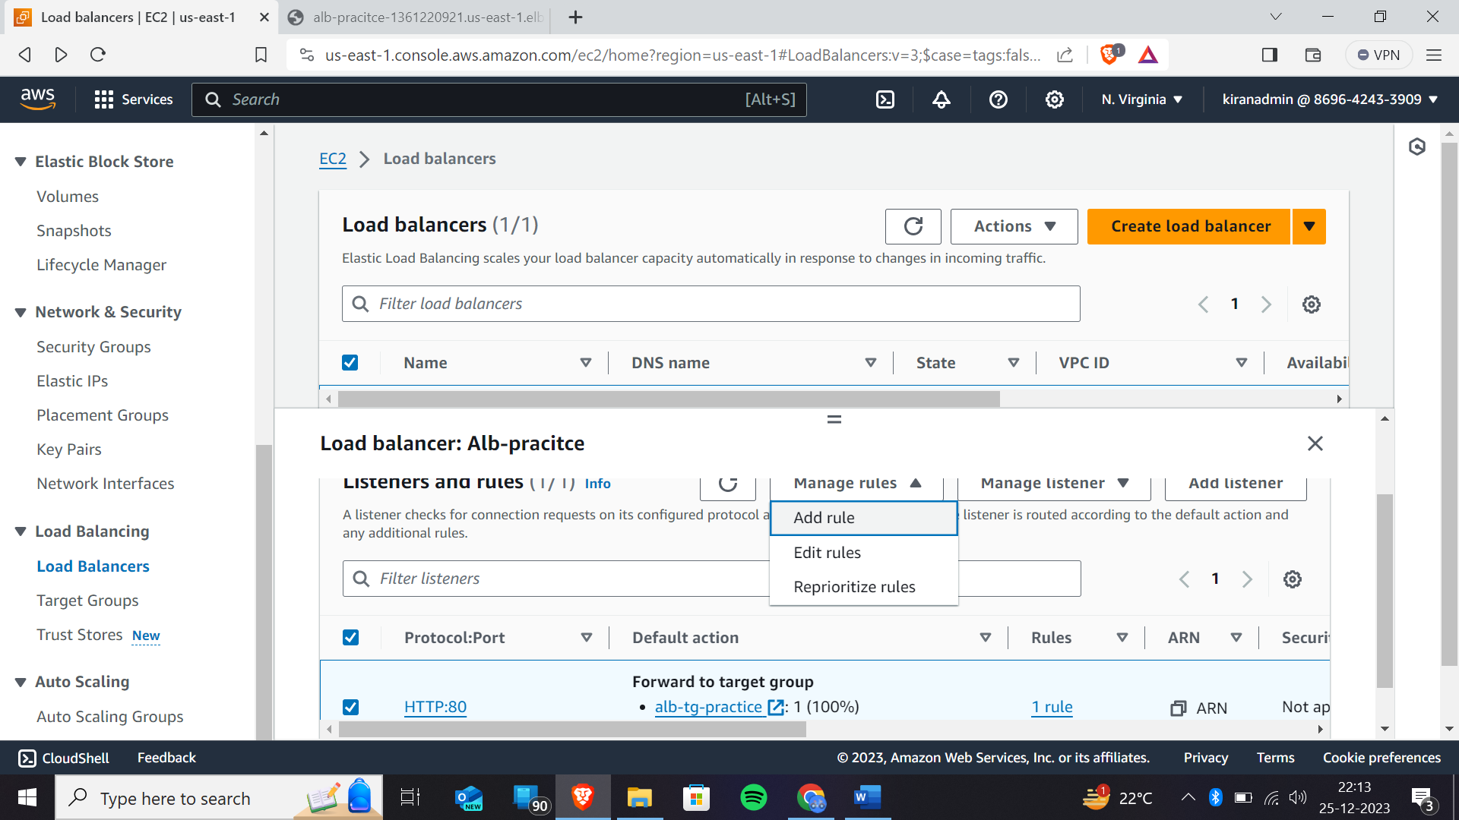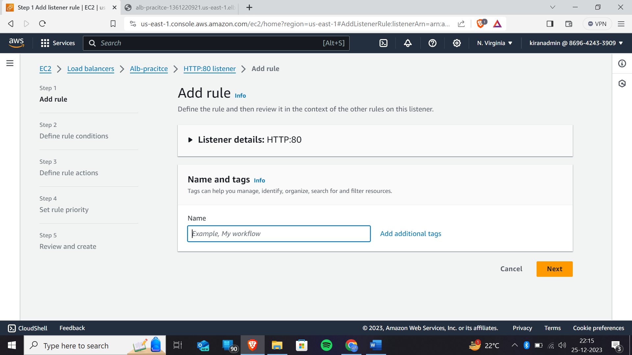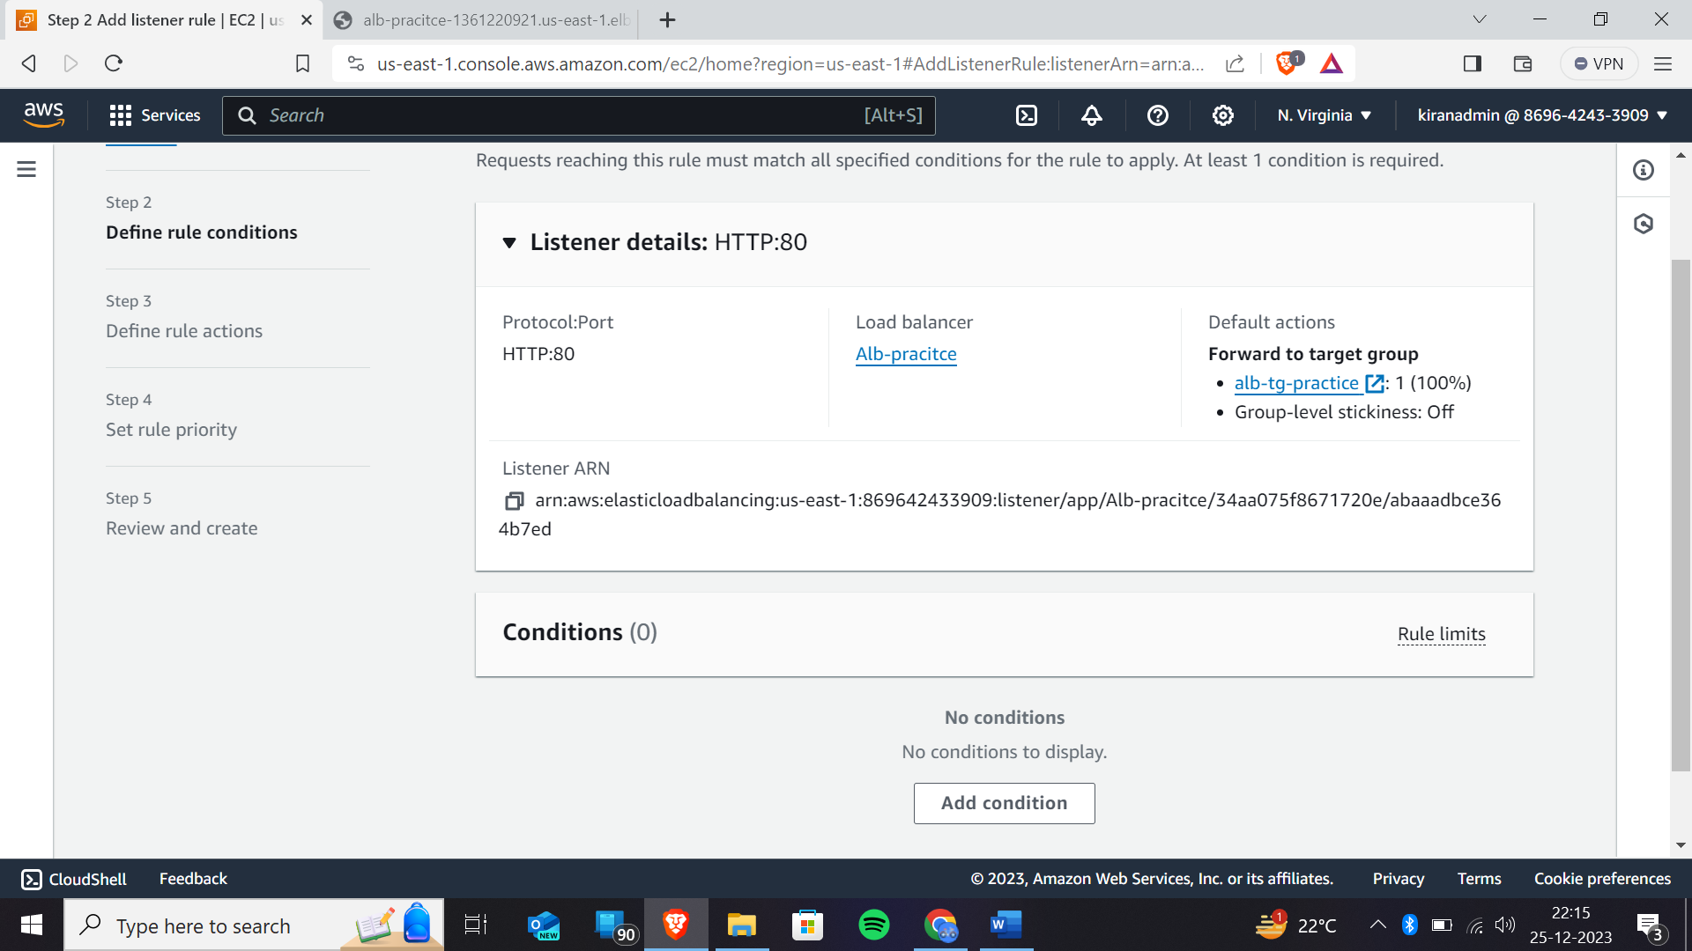click on add condition

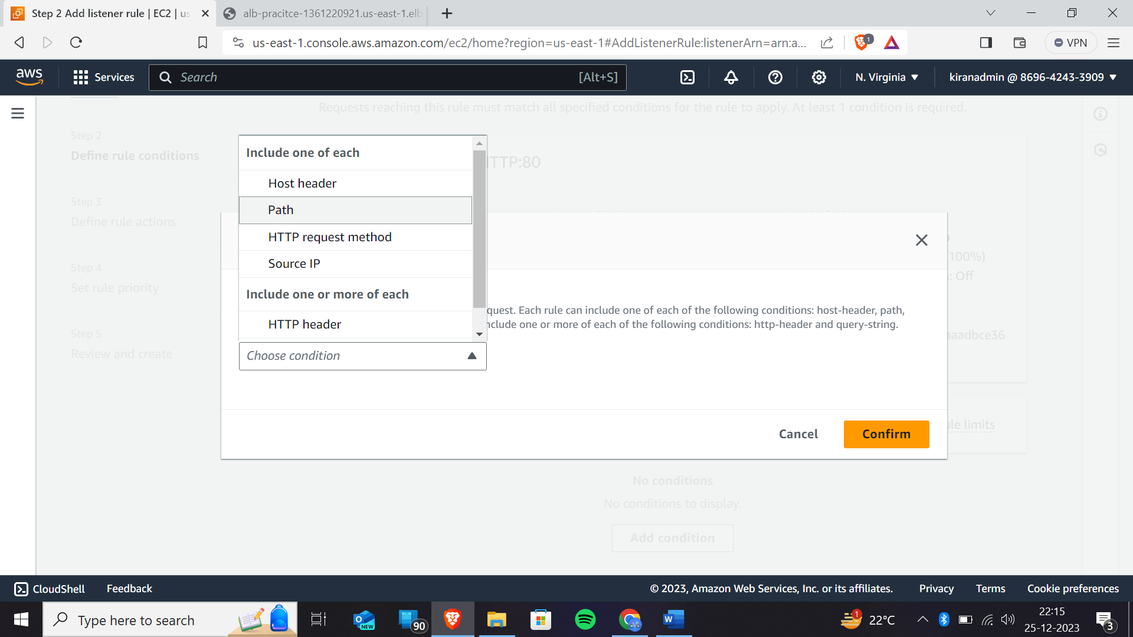click on path

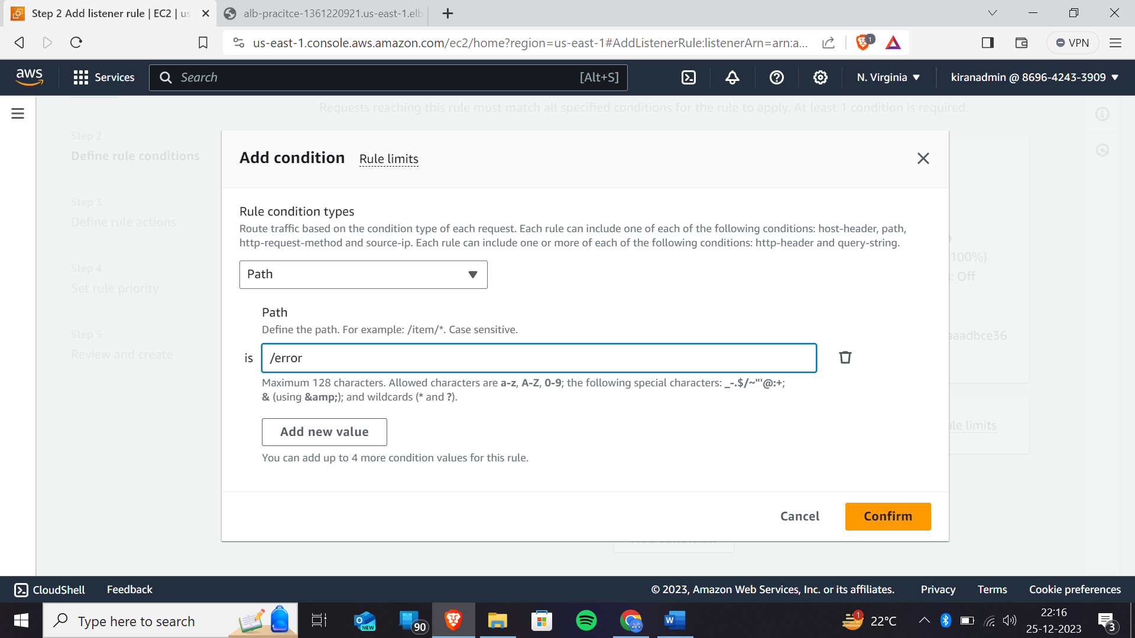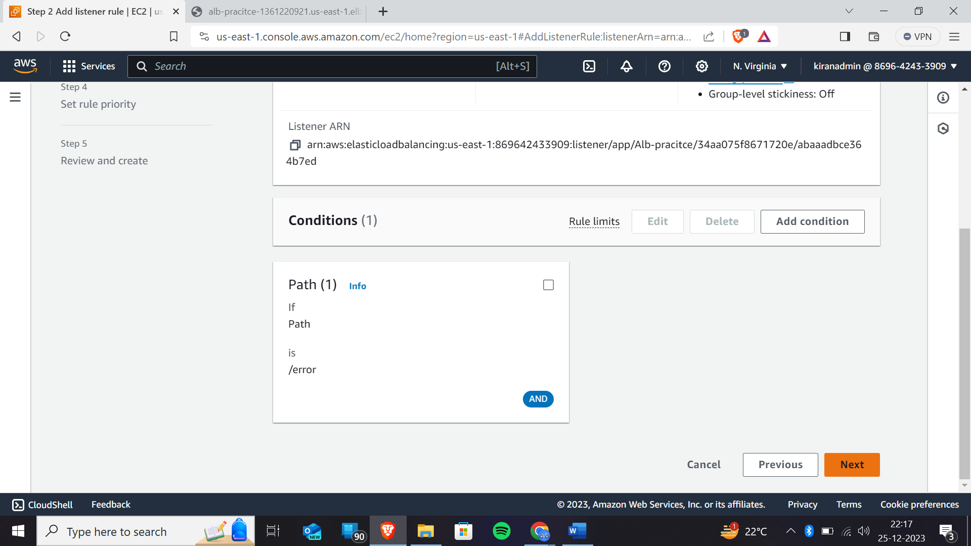click on next

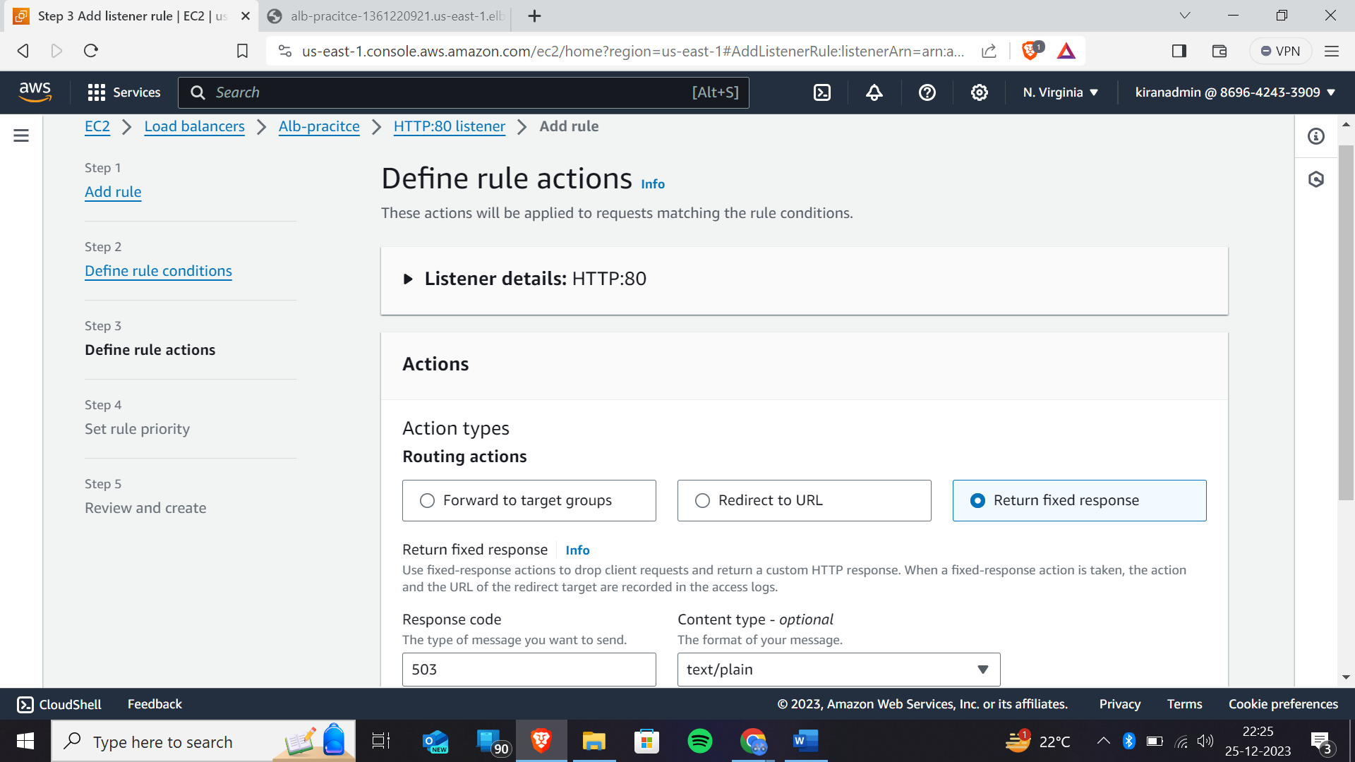click on to return fixed response

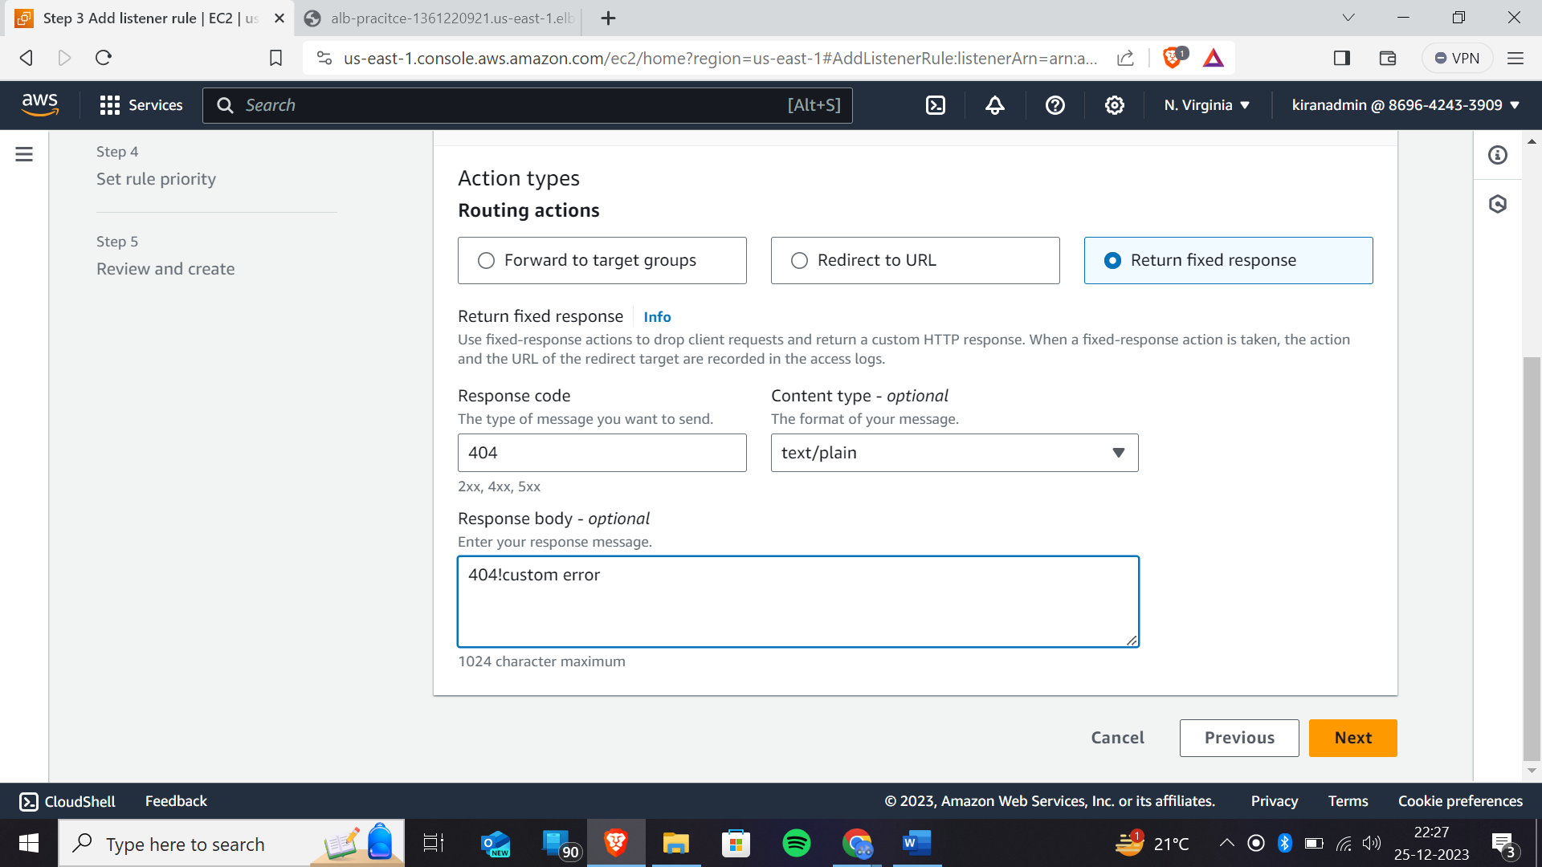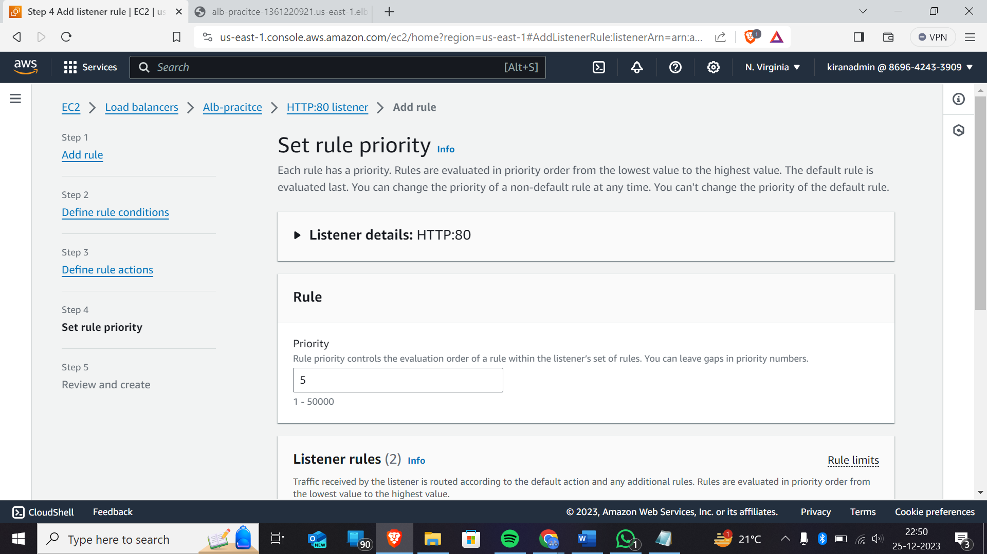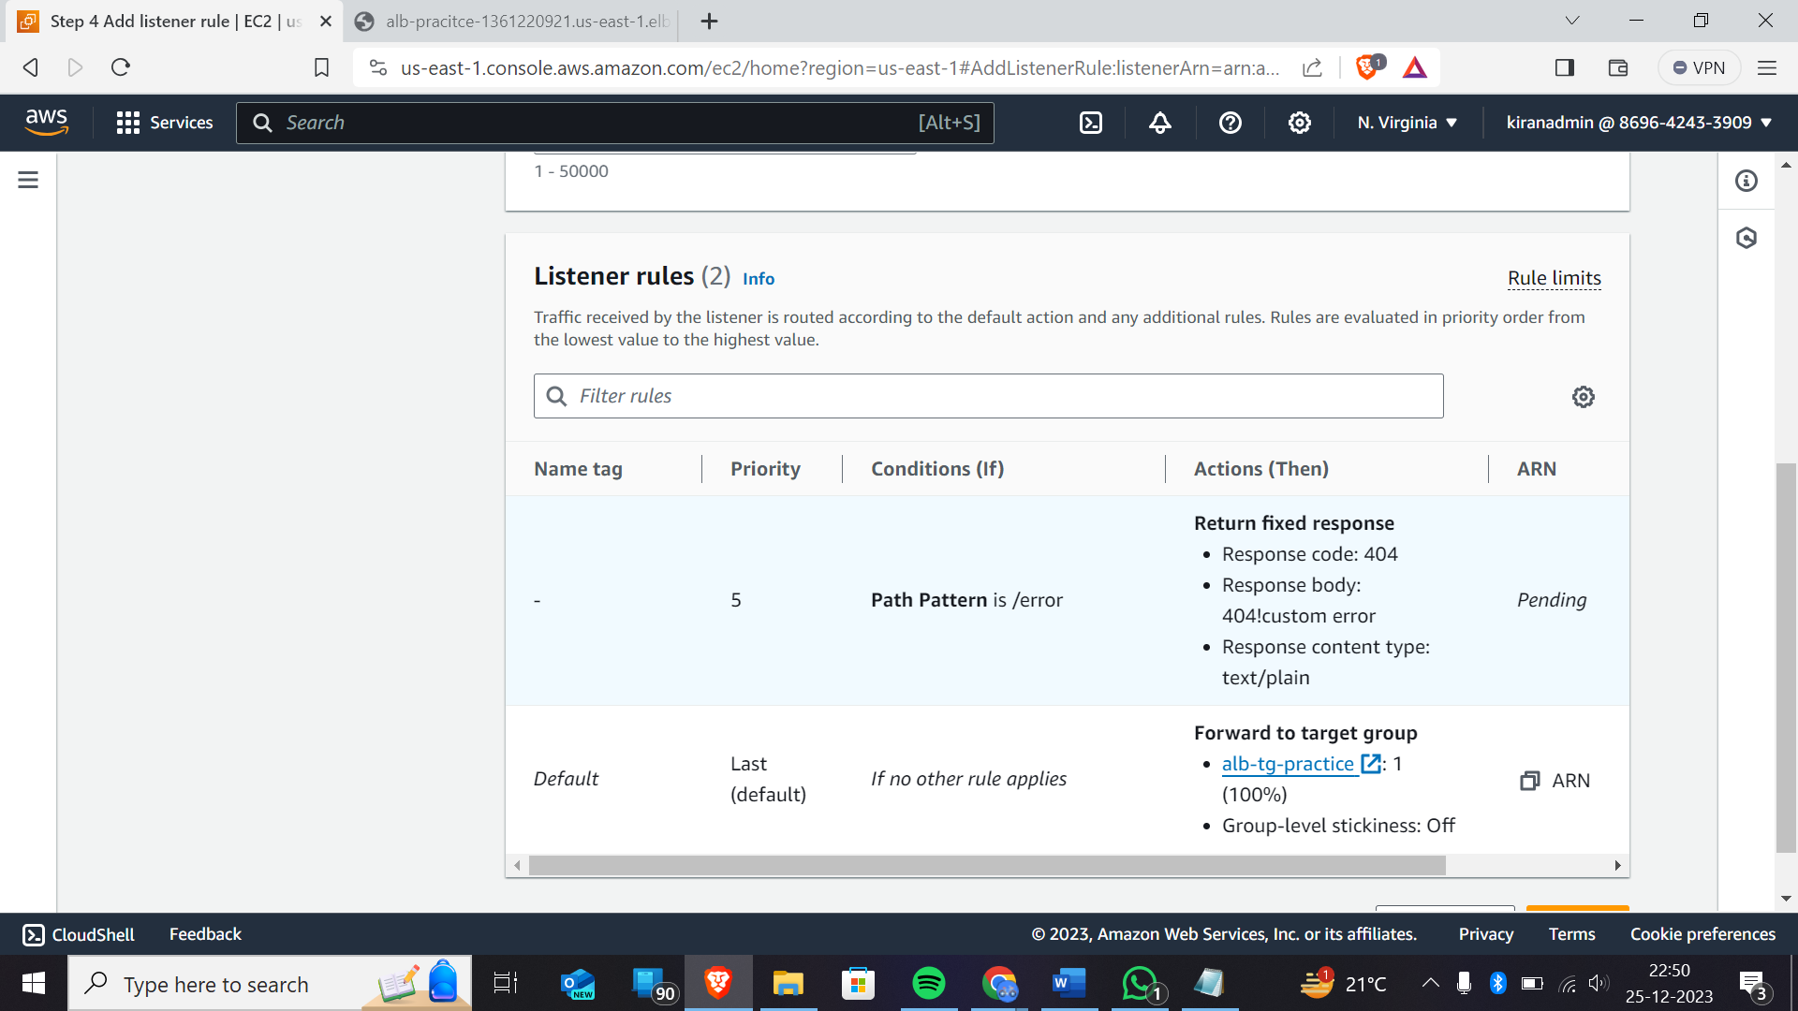priority-1🡪highest priority

Priority-5🡪least priority

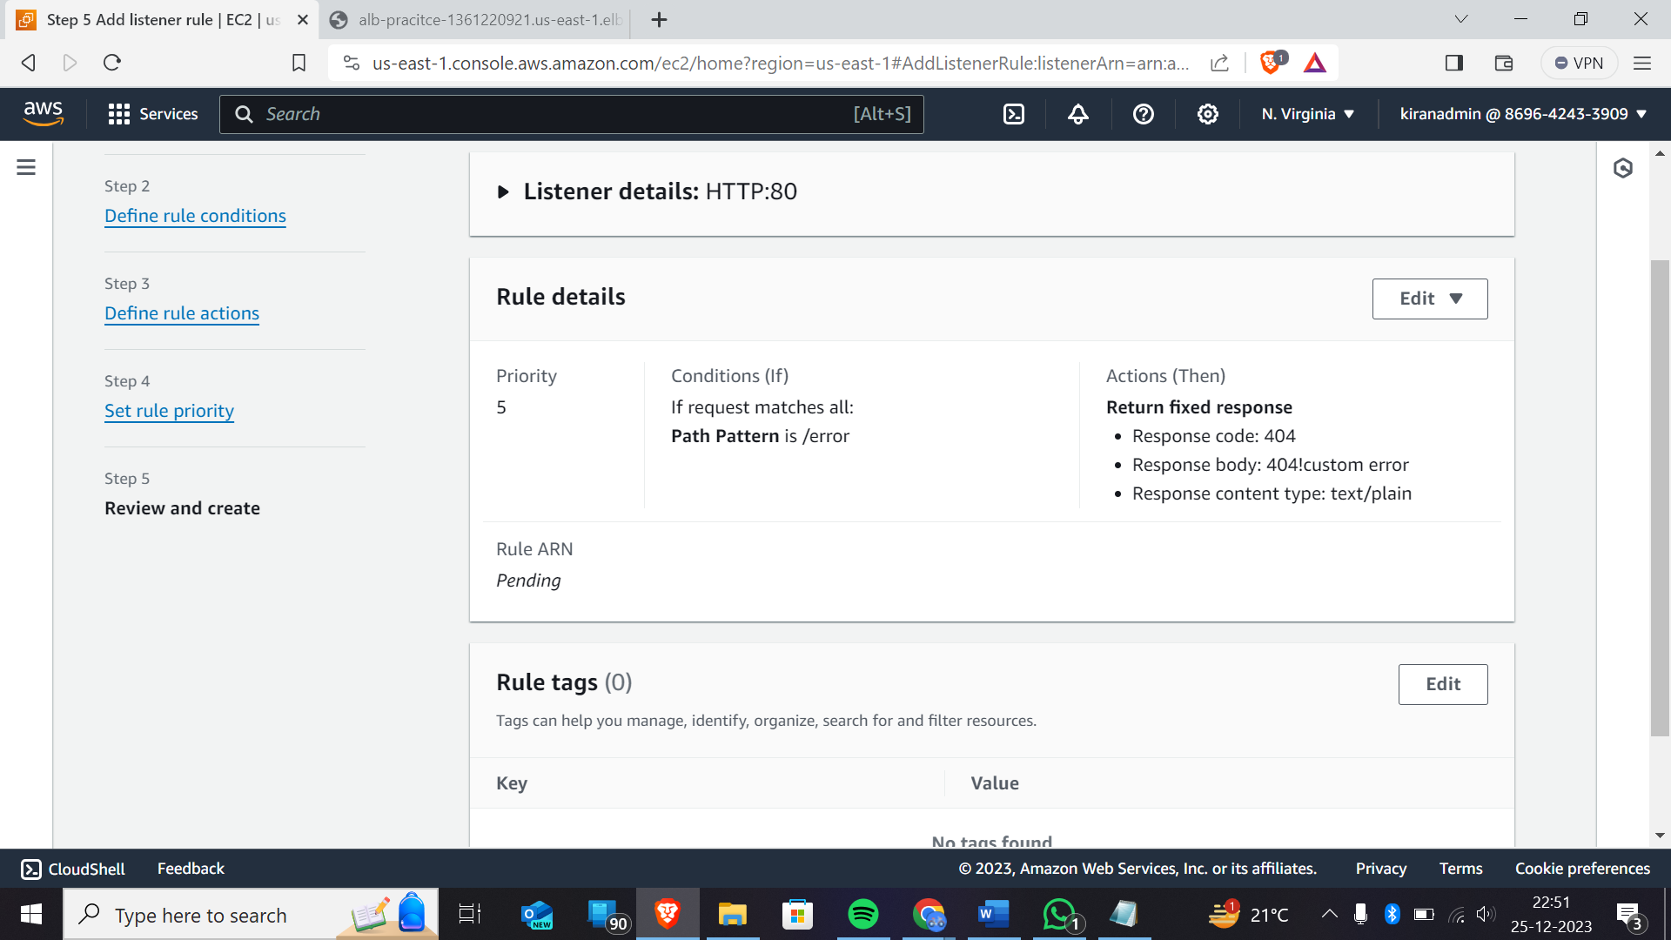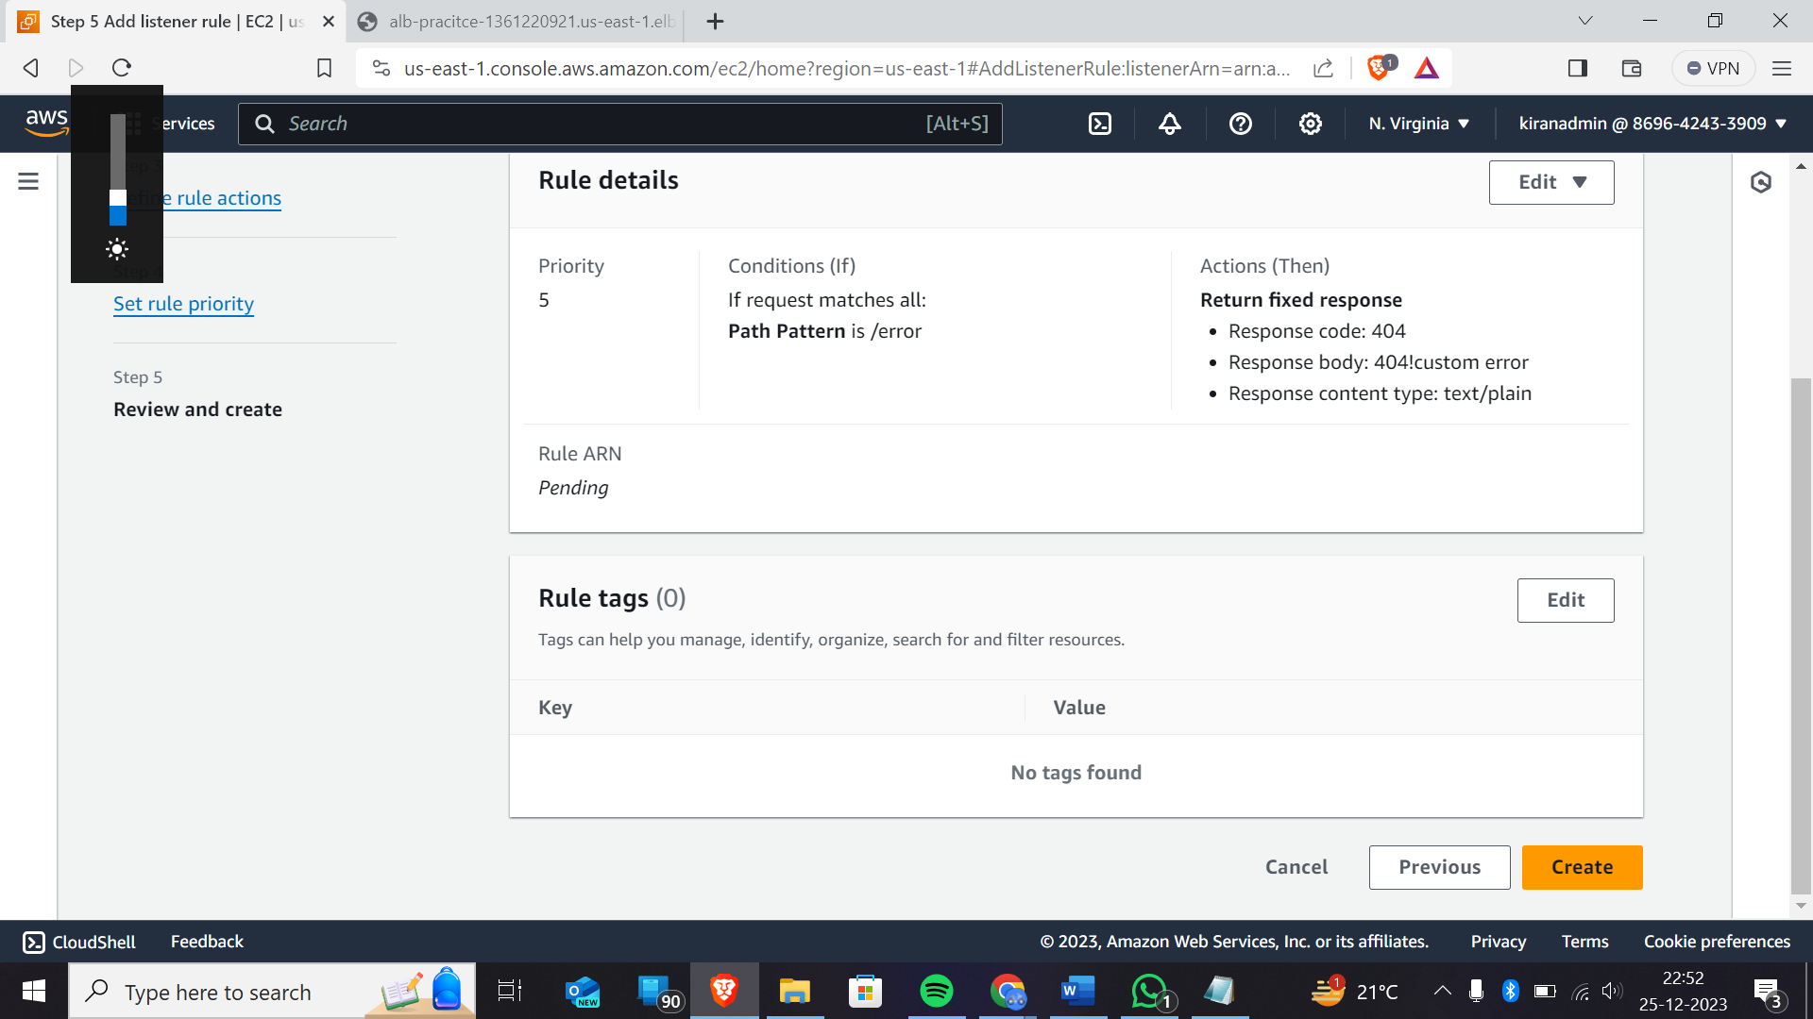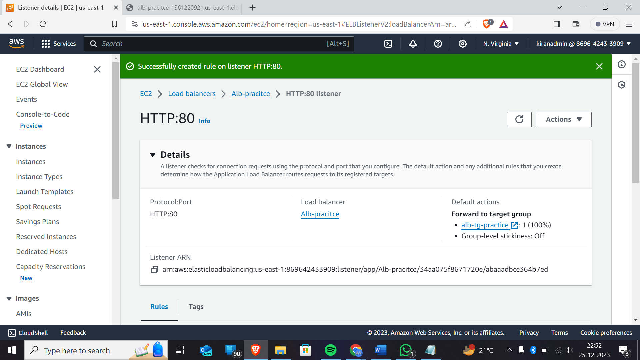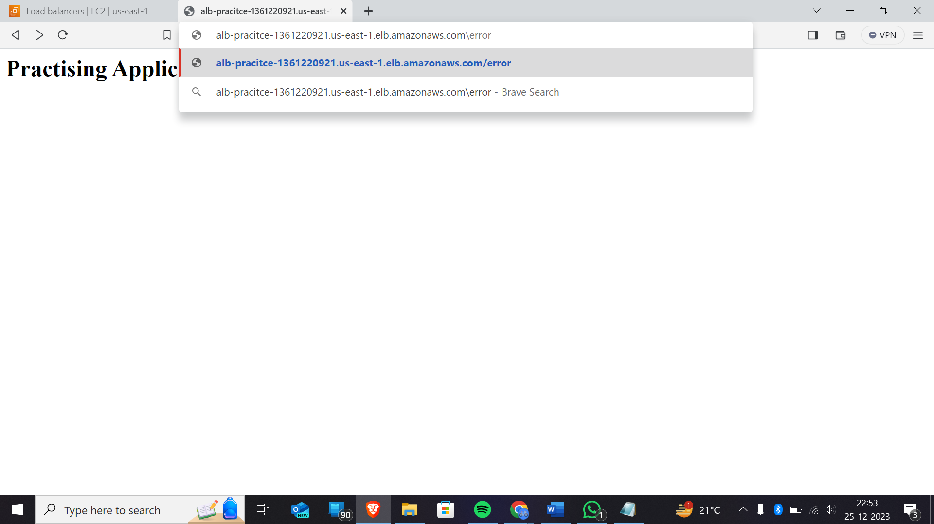In URL- you have to give the path that you have given while creating the rules

As we have given path as /error

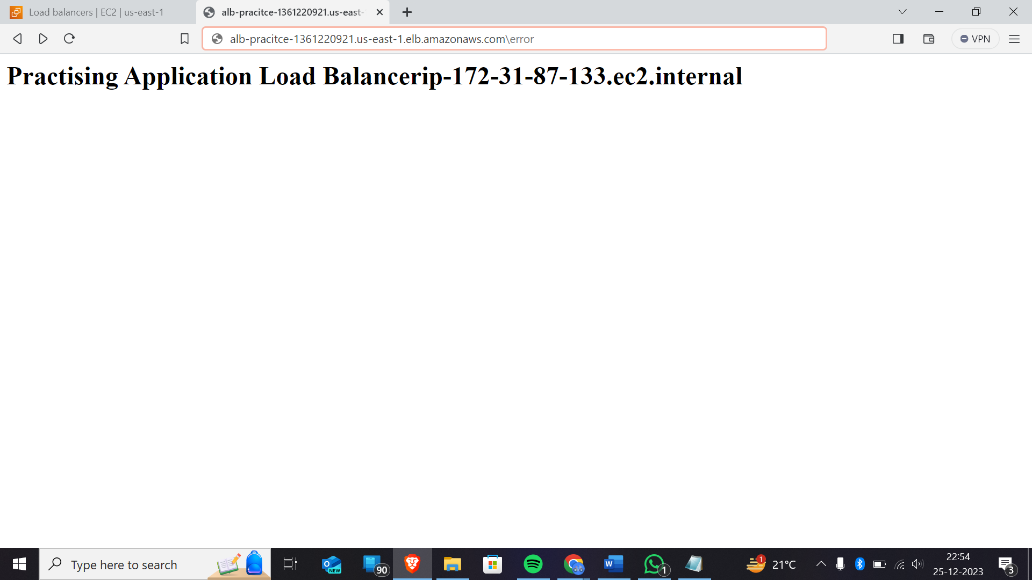This is the final output that we will get.

In this, you can try it by query name in the url while creating the rules

Hence , it’s the end of the lab.